Square, Square roots, cubes, cube roots
O level Mathematics by Anon
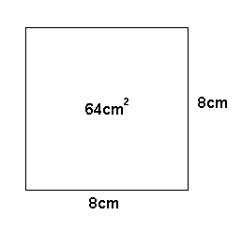
Squares and Square roots:

The area of the square given is:
8cm x 8cm = 64 cm²

That’s is why we call 64 the square of 8
It can be represented as:

$$8^{2} = 64$$

Now we look at the other way round.
How can we find out the side of the square that is of 64cm²?

We put,
$64 =x×x$
Or $64 =x^{2}$

As $x=8$

So we can say that 8 is the square root of 64.
It can be represented as:

$$\sqrt{64}=8$$

So now we can say that:
$2×2=2^{2}=4$ And $\sqrt{4}=2$
$3×3=3^{2}=9$ And $\sqrt{9}=3$
$4×4=4^{2}=16$ And $\sqrt{16}=4$
$5×5=5^{2}=25$ And $\sqrt{25}=5$
And so on…

We see above that the numbers 4, 9, 16, 25 are square of whole numbers 2, 3, 4, 5 respectively. The number 2, 3, 4, 5 are whole numbers so we call 4, 9, 16, 25 etc. as perfect squares.
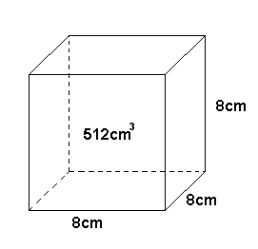
Cubes and cube roots:

The volume of the cube given is:
$$8cm×8cm×8cm={512cm}^{3}$$

That is why we can call 512 as cube of 8.
It can be represented as:
$$8^{3}=512$$

Now as before we look at the other way round.
What is the side of the cube that is 512cm³?

We put,
$512=x×x×x$
Or $512=x^{3}$
As $x=8$

So we can say 8 is the cube root of 512.
It can be represented as:
$$\sqrt[3]{512}=8$$

So now we can say that:
$2×2×2=2^{3}=8$ And $\sqrt[3]{8}=2$
$3×3×3=3^{3}=27$ And $\sqrt[3]{27}=3$
$4×4×4=4^{3}=64$ And $\sqrt[3]{64}=4$
$5×5×5=5^{3}=125$ And $\sqrt[3]{125}=5$
And so on…

We again notice that the number 8, 27, 64, 125 are cubes of 2, 3, 4, 5 respectively. As the number 2, 3, 4, 5 are whole numbers, so we call 8, 27, 64, 125 etc. as perfect cubes

