REDOX Reactions (Oxidation-Reduction):
All chemical reactions involve loss and gain of electrons. The scientific name of loss of electrons is Oxidation. The scientific name of gain of electrons is Reduction. This can be memories by the following phrase:
Oxidation is Loss – Reduction is Gain

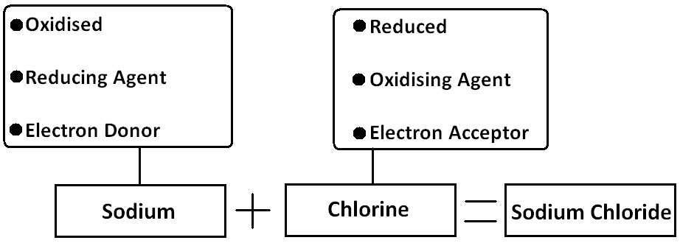
If an atom loses an electron and becomes a positive ion, we say it is oxidized. If an atom gains an electron and becomes a negative ion, we say it is reduced. In a reaction, the substance that is oxidized can also be called reducing agent this is because it causes reduction to the other substance which gains the electron. The substance that gains the electron can be called the oxidizing agent, this is because it causes oxidation to the other substance. They could also be called electron donor and electron acceptor.

This means that all metals are Reducing agents because they form positive ions. And all non-metals are Oxidising agents because they form negative ions.

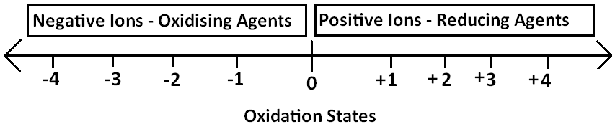
When an atom becomes an ion, it gets charged, its charge is also called the Oxidation State. All elements or atoms have are neutral, they have an oxidation state of 0. When a metal atom is oxidized and becomes a positive ion, its oxidation state increases. When a non-metal atom is reduced becoming a negative ion, its oxidation state decreases.

EXAMPLES:
4Fe + 3O₂ $→$ 2Fe₂O₃
Oxidising Agent: Iron
Reducing Agent: Oxygen

2Mg + O₂ $→$ 2MgO
Oxidising Agent: Magnesium
Reducing Agent: Oxygen

Displacement Reactions In Metals:
Displacement reactions are in which a substance displaces another substances in its compound. In metals, it is when a more reactive metal displaces the less reactive metal in its solution. We say the more reactive metal Reduced the less reactive metal. This is because it causes it to gain the electrons it lost during bond formation back.

In this type of reactions, the oxidizing agent is less reactive metal and the reducing agent is the more reactive metal. The best oxidizing agents in metals are the least reactive metals. The best reducing agents in metals are the most reactive metals.

the negative ion in the reaction, which the metals compete for, is called the Spectator Ion because it doesn’t change.

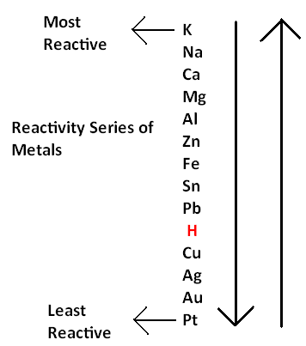
These reaction always depend on the reactivity series of metals.

Example:
Zn + CuSO₄ $→$ ZnSO₄ + Cu
The metals we have here are zinc and copper. Zinc is more reactive than copper so it will reduce it.

Half Ionic Equations:
Zn - 2ѐ $→$ Zn²⁺
Cu²⁺ + 2ѐ $→$ Cu

Ionic Equation:
Zn + Cu²⁺ $→$ Zn²⁺ + Cu

Oxidising Agent: Copper because it is reduced and gains electrons
Reducing Agent: Zinc because it is oxidized and loses electrons
Spectator Ion: Sulfate ion.

Observation:
The blue colour of the copper sulfate solution fades away
Red brown solid (copper) is formed
The Temperature Rises (Exothermic Reaction)

Displacement Reactions in Non-Metals:
Like in positive ions, the more reactive negative ion can oxidize and displace the less reactive negative ion. In displacement reactions, you will only deal with halogens and halides as the non-metals.

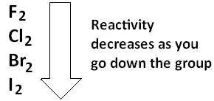
In group 7, the reactivity of the halogen decreases as you go down the group. Arranged in order from the most reactive to the least, the reactivity series is:

Fluorine is the most reactive one, it can reduce oxidize any of them. Chlorine is the second most reactive, it can oxidize bromine and iodine but it is oxidized by fluorine. Bromine is the third most reactive, can only oxidize Iodine and it gets oxidized by either chlorine or Fluorine. Iodine is the least reactive, it can’t oxidize any of them and all of them can oxidize it.

Notice that for the non-metals, it is the opposite of the metals. The more reactive one Oxidises the less reactive one. Unlike the metals in which the more reactive one reduces the less reactive one. This is because non-metal gain electrons when forming an ion, and metals lose them when forming an ion. So the best oxidizing agents in non-metals are the most reactive ones. The best reducing agents in non-metals are the least reactive ones.

Example:
Cl₂ + 2KBr $→$ 2KCl + Br₂
The non-metals we have in this reaction are chlorine and bromide. Chlorine will oxidize and displace bromine.

Half Ionic Equations:
Cl₂ - 2ѐ $→$ 2Cl⁻
2Br⁻ - 2ѐ $→$ Br₂

Full Ionic Equation:
Cl₂ + 2Br⁻ $→$ 2Cl⁻ + Br₂

Oxidising agent: Chlorine
Reducing Agent: Bromide
Spectator Ion: K⁺

Observations:
Solution turns red brown because Bromine is formed.

NOTE:
In metals, the oxidizing agent is always the least reactive ion, and the reducing agent is the most reactive element (Atoms)
In non-metals, the oxidizing agent is the most reactive element (Atoms), and the reducing agent is always the least reactive ion.

REDOX Reactions and Oxygen:
In the following reaction, Copper loses an oxygen ion to Hydrogen.
CuO + H₂ $→$ Cu + H₂O
Half ionic equations:
Cu²⁺ + 2ѐ $→$ Cu
H₂ - 2ѐ $→$ 2H⁺
Hydrogen is higher than Copper in the reactivity series, this is why Hydrogen reduces Copper. Like in electrons, loss and gain of Oxygen ions is a REDOX reaction. In this reaction Copper is reduced because it gains electrons and Hydrogen is oxidized because it loses electrons.
Gain of Oxygen is:
Oxidation because it also means loss of electrons

Loss of Oxygen is:
Reduction because it also means gain of electrons

The oxidizing agent is called the oxidant, the reducing agent is called the reductant. The oxidant loses the oxygen and reductant gains it.
Example:
ZnO + C $→$ Zn + CO
Carbon is higher than zinc in the reactivity series, it will reduce it and take it’s oxygen atom.

Oxidant: ZnO
Reductant: C

REDOX Reactions and Hydrogen:
As in metals and oxygen, a more reactive non-metal can oxidize the less reactive non-metal and take its Hydrogen. This is a REDOX reaction because it involves loss and gain of electrons.

In the following reaction Chlorine oxidizes the Sulfide ion and takes the hydrogen ions from it.
H₂S + Cl₂ $→$ 2HCl + S

Half Ionic Equations:
Cl₂ + 2ѐ $→$ 2Cl⁻
S²⁻ - 2ѐ $→$ S

To gain the hydrogen ions, Chlorine has to gain 2 electrons, which is reduction. This makes gaining hydrogen ions reduction. When sulfide loses the hydrogen ions, it loses 2 electrons and becomes an atom, losing electrons is oxidation. This makes loss of hydrogen ions oxidation.
The reducing agent is H₂S and the oxidizing agent is Cl₂.
Example:
2HCl + F₂ $→$ 2HF + Cl₂

Fluorine is more reactive than chlorine, it will oxidize the chloride.

Half Ionic Equations: F₂ + 2ѐ $→$ 2F⁻
2Cl⁻ - 2ѐ $→$ Cl₂
Oxidising Agent: Fluorine
Reducing Agent: Chloride
Spectator Ion: hydrogen

Gain of Hydrogen is Oxidation
Loss of Hydrogen is Reduction

Oxidising Agents | Reducing Agents
H₂O₂ | CH₄
O₂ | H₂
Halogens | Non-metal ions
Metal Ions | Metals
Acidified KMnO₄ | SO₂
Acidified K₂Cr₂O₇ | CO
 | C
 | NH₃
Ethanol
KI

Oxidation | Reduction
Loss of electrons | Gain of electrons
Gain of Oxygen by Metals | Loss of Oxygen by Metals ions
Loss of Hydrogen by non-metal ions | Gain of Hydrogen by non-metals
Increase in Oxidation State | Decrease in Oxidation State
Oxidising Agent: This is a substance that causes oxidation to another substance by undergoing reduction.

Reducing Agent: This is a substance that causes reduction to another substance by undergoing oxidation.

Testing for Oxidising Agents:
If we have a substance and we want to find out if it is an oxidizing agent, the following experiment is performed:
- Add some aqueous Potassium Iodide (KI) which is a reducing agent to a test tube.
- Add few drops of the substance to the potassium iodide solution
- If the substance is an oxidizing agent, the solution’s colour changes from colourless to dark brown, and a black solid forms.
- The reddish brown colour is the colour of an iodine solution and the black solid is iodine.
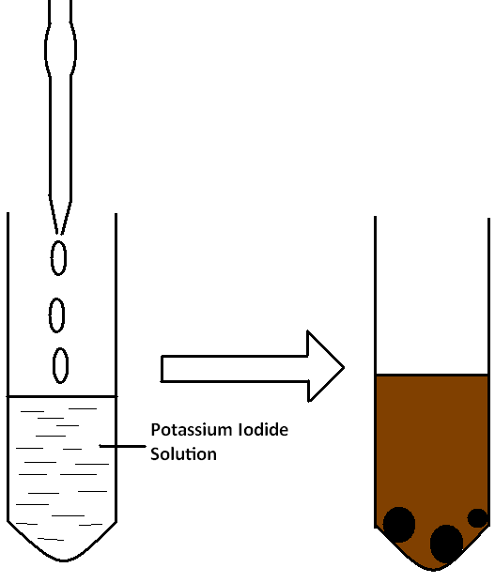
- If the substance is an oxidizing agent, it oxidizes Iodide to iodine:
2I⁻ - 2ѐ $→$ I₂

Testing For Reducing Agent:
If we have a substance and we want to find out if it is a reducing agent, the following experiment is performed:
- Add some Acidified potassium manganate (vii) KMnO₄ which is an oxidizing agent to a test tube.
- Add some drops of the substance to the test tube
- If the substance is a reducing agent, the colour of the solution will turn from purple to colourless.
- If the substance is a reducing agent it will reduce manganate (vii) to manganate (ii):
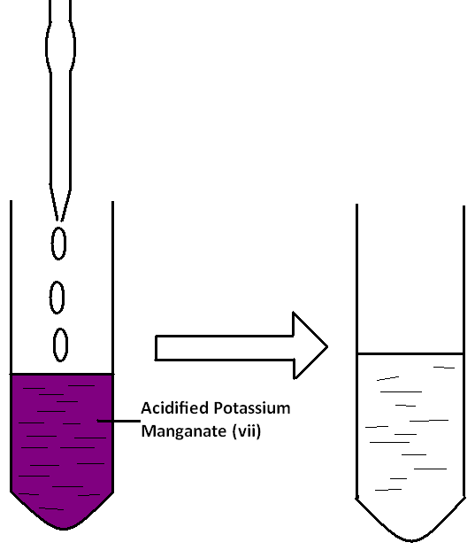
Mn⁷⁺ + 5ѐ $→$ Mn²⁺

Photochemical Reactions:
Photochemical reactions are reactions that are affected and triggered by light. Light intensity is a very effective factor that affects the rate of photochemical reactions. The higher the light intensity the faster the reaction.

Photosynthesis:
Photosynthesis is a photochemical reaction that takes place in the leaves of a plant. It is a process in which glucose and oxygen are formed from carbon dioxide and water. This reaction cannot occur in the dark, light is essential for it. But not only light, a chemical called chlorophyll which traps the light and uses its energy in the reaction is essential too.
Sunlight
Carbon dioxide + water glucose + Oxygen
Chlorophyll

6CO₂ + 6H₂O $→$ C₆H₁₂O₆ + 6O₂

Reduction of Silver ions:
If silver chloride which is white in colour is exposed to some light, a reaction takes place that separates it into silver and chlorine atoms. Silver atoms are black in colour. This is a photochemical reaction. In this reaction, white silver ions are reduced into black silver atoms, and chloride ions oxidized into chlorine atoms.

2AgCl $→$ 2Ag + Cl₂
(White) (Black) .

The Photography Concept:
Photography depends on the reduction of silver ions to silver atoms. The photographic film of a camera is coated with a silver bromide layer, which is cream in colour. This layer plays a big role in taking a photo. The process is as follows:
- When the shutter is closed, the film will look something like this.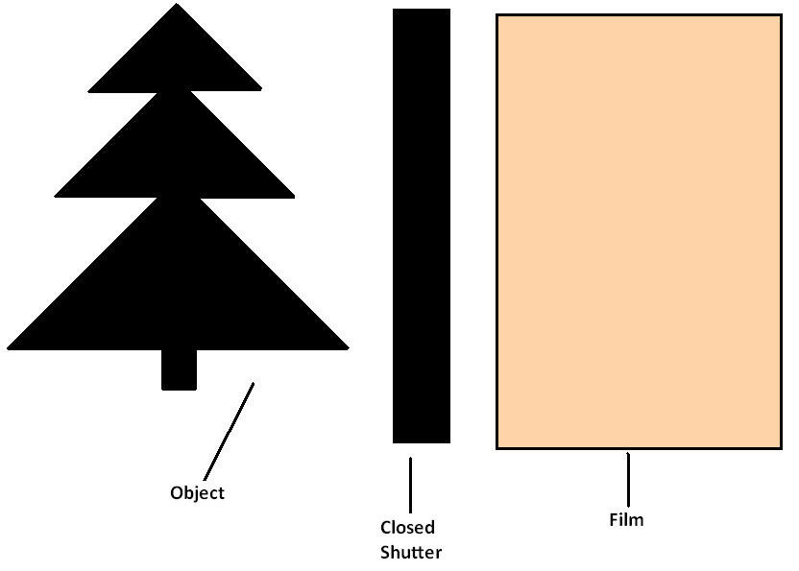
- When the shutter opens, the light will reflect from the object and its surrounding. At the area where the reflected light falls on, the silver bromide ions will get separated. Silver will take one electron from the bromide ion and will get reduced into black silver atoms:
Ag⁺ + ѐ $→$ Ag
The shutter opens and shuts immediately, there is not enough time for all silver ions to get reduced into atoms. The film will look like this:
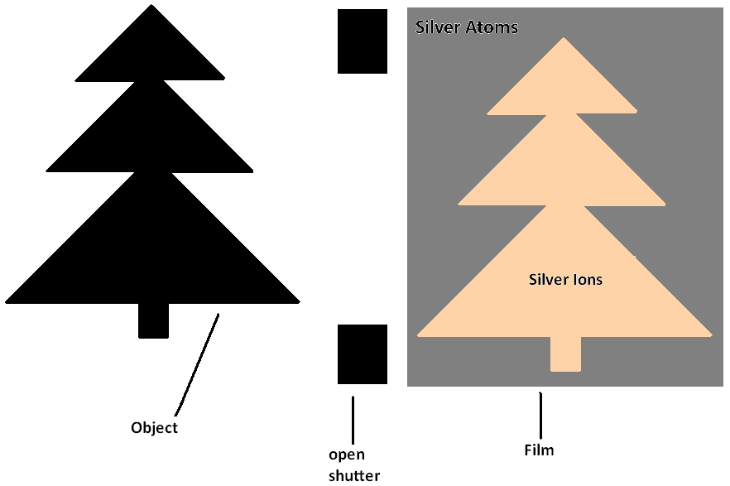

- Then the film is soaked in a developer which is a reducing agent to convert the ions which were exposed to light but did not get reduced into silver atoms.

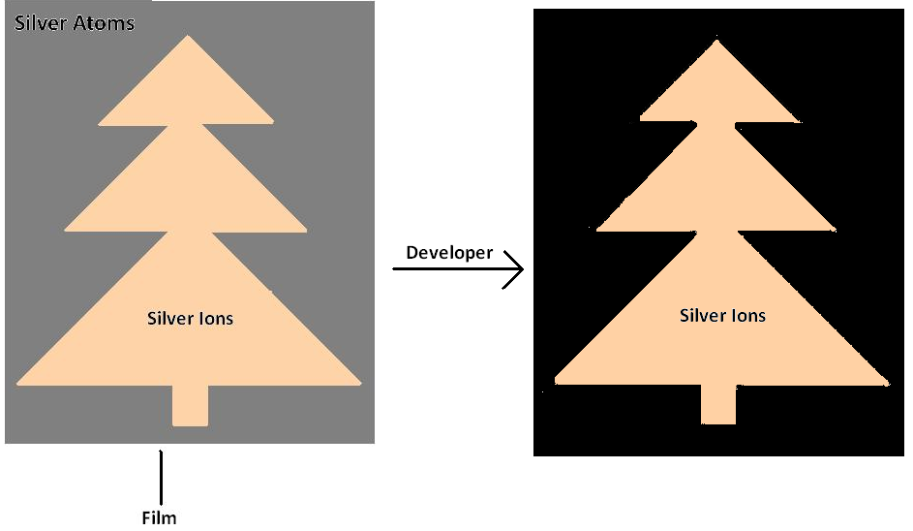
- Then a fixer is used to dissolve the remaining silver ions which were not exposed to light and reduced. This leaves us with a black metallic layer on the film, this is the negative.
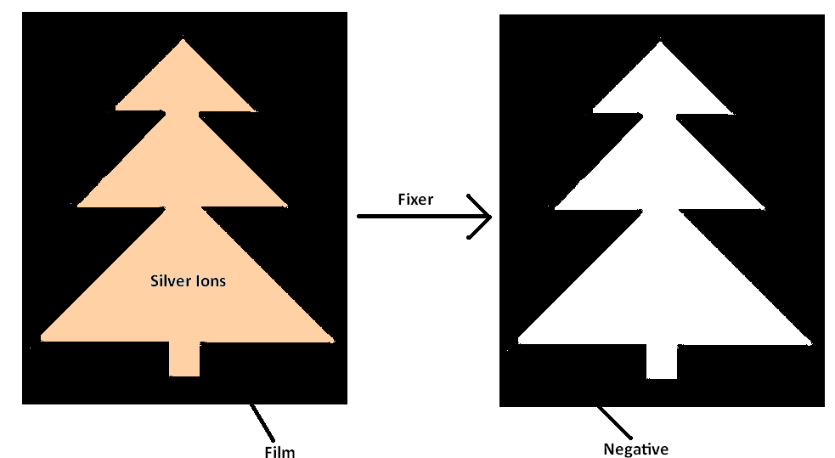

- The film is then printed.

The reaction between the developer and the silver ions is sped up by:
- Raising the temperature of the developer
- Increasing the concentration of the developer
- Increasing the surface area of the silver ions.

