MATRICES

- Matrices are shown in the following way: 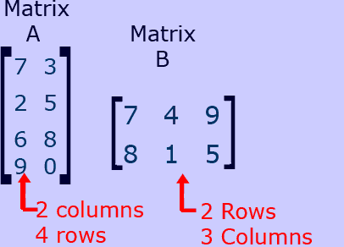
The digits shown horizontally are called ROWS
The digits shown vertically are in COLUMNS
The ORDER of the matrix is given by [ROWS x COLUMNS]

- For addition and subtraction of matrices, the order of the matrices has to be same and the corresponding values are added or subtracted under the given circumstances.
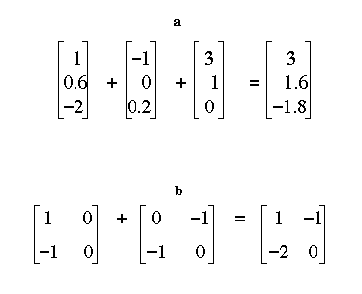

- There are 2 types of multiplication. Firstly, scalar, which is demonstrated in the following:
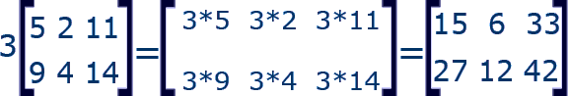

The number outside the matrix is multiplied to all the numbers inside.

The second type is matrix multiplication, the following: 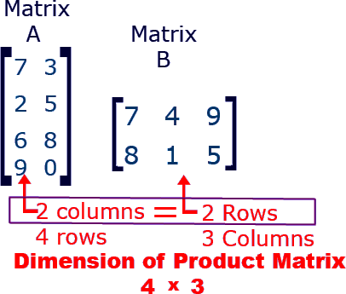

It is necessary for the number of columns of first matrix to be equal to number of rows of second. Otherwise multiplication cant be done.
The product of 2 matrices

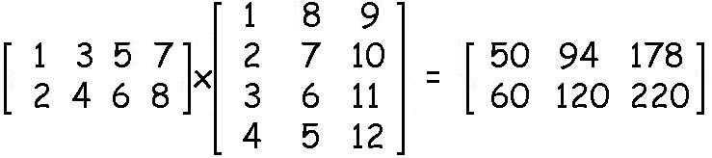The product is found by multiplying the first row of matrix A with first column of matrix B with corresponding values to give answer 50. [(1*1)+(3*2)+(5*3)+(7*4)]=50. Likewise the first column is multiplied with second row and then third row. Then the second column is multiplied with first, second, and third rows respectively.
- These are identity matrices:
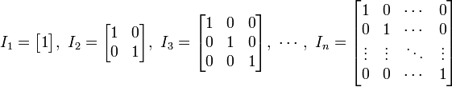
Multiplication of matrices with identity matrix gives the same matrix as an answer.

- A zero matrix is one with all numbers 0 and addition or subtraction gives the same matrix as answer.

- Finally the inverse:

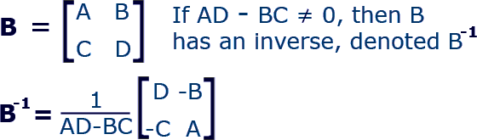

AD-BC is known as determinant and it is multiplied with the matrix with digits of main diagonal displaced nd signs of the other changed.

