Math Rules
Factorisation:
For factorising a Quadratic Equation by Formula:
$$X=\frac{-(b)±\sqrt{{(b)}^{2}-4\left(a\right)(c)}}{2(a)}$$

Trignometry:
Pythagoras Theorem:

$A^{2}=B^{2}+C^{2}$$$B^{2}=A^{2}-C^{2} \\ C^{2}=A^{2}-B^{2}$$
B A

C

Trignometry of a right angled Triangle:
$$SOH:Sinθ=\frac{Opposite}{Hypotenuse}$$
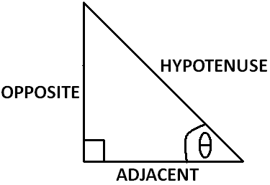
$$CAH:Cosθ=\frac{Adjacent}{Hypotenuse}$$
$$TOA:Tanθ=\frac{Opposite}{Adjacent}$$
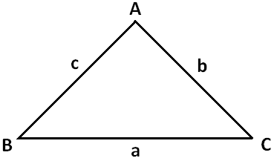

The Sine rule:
A,B & C are angles
A,b & c are sides

The Sine Rule is used when:
- You are given ONE SIDE and TWO ANGLES, to find the missing side
- You are given TWO SIDES and ONE ANGLE which is not between the two sides, to find the missing angle.

$$\frac{a}{SinA}=\frac{b}{Sinb}=\frac{c}{SinC}$$

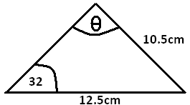
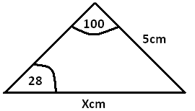
Examples on Sine rule:
1) Find X:
$$\frac{5}{Sin(28)}=\frac{X}{Sin(100)}$$

$$X=\frac{5×Sin(100)}{Sin(28)}$$

$$X=10.5cm$$

2) Find $θ$:
$$\frac{12.5}{Sinθ}=\frac{10.5}{Sin(32)}$$

$$Sinθ=\frac{Sin\left(32\right)×12.5}{10.5}$$

$$θ=Sin^{-1}\left(\frac{Sin\left(32\right)×12.5}{10.5}\right)$$

$$θ=39.1°$$

The Cosine Rule:
A,B & C are angles
A,b & c are sides

The Cosine Rule is used when:
- You are given TWO SIDES and ONE ANGLE which is between the two sides, to get the side opposite to the angle.
- You are given THREE SIDES, to find any angle.

$$a^{2}=b^{2}+c^{2}-2\left(b\right)\left(c\right)(Cosθ)$$

$$b=a^{2}+c^{2}-2\left(a\right)\left(c\right)(Cosθ)$$

$$c^{2}=b^{2}+a^{2}-2\left(b\right)\left(a\right)(Cosθ)$$

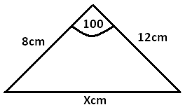
Examples on the Cosine Rule:
1) Find X:
$$X^{2}=8^{2}+{12}^{2}-2\left(8\right)\left(12\right)(Cos100)$$

$$X=240.25$$

$$X=15.5cm$$

2) Find $θ$:

$${17}^{2}={10}^{2}+{12}^{2}-2\left(10\right)\left(12\right)(Cosθ)$$
$$289=244-240\left(Cosθ\right)$$
$$289+240\left(Cosθ\right)=244$$
$$240\left(Cosθ\right)=244-289$$
$$240 \left(Cosθ\right)=-45$$
$$Cosθ=\frac{-45}{240}$$
$$θ={Cos}^{-1}\left(\frac{-45}{240}\right)$$
$$θ=100.8°$$

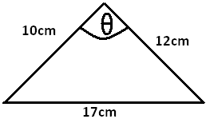

Sine Rule of the Area of a triangle:
A,B & C are angles
A,b & c are sides

This Rule is used when:
- You are given TWO SIDES and ONE ANGLE which is between the two sides.

$$Area= \frac{1}{2}×b×c×SinA$$
$$Area=\frac{1}{2}×b×a×SinC$$
$$Area=\frac{1}{2}×a×c×SinB$$
Examples on the Sine Rule of Area:
Find the area of this shape:

$$Area=\left(\frac{1}{2}×120×40×Sin(120)\right)+\left(\frac{1}{2}×20×80×Sin(100)\right)$$

$$Area=2866.31m^{2}$$
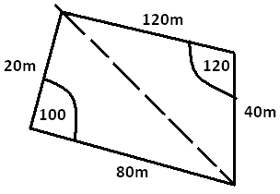

Sine Curve Rule:
$$Sinθ=Sin(180-θ)$$
Examples:
$$Sin100=Sin80$$
$$Sin74=Sin106$$
And so on…
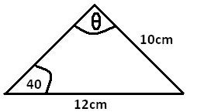
Example on Sine Curve rule:
Calculate angle $θ$ given that it is obtuse.

$$\frac{12}{Sinθ}=\frac{10}{Sin40}$$

$$Sinθ=\frac{12×sin40}{10}$$

$$θ={Sin}^{-1}\left(\frac{12×sin40}{10}\right)$$

$θ=50.47…°$ which is obtuse. We have to find the other angle which has the same sine.
$$180-50.47…=129.5$$

Back Bearing:
If the bearing of B from A is $θ$, then the bearing of A from B {Back Bearing} is:
$$θ+180°\left(if θ is less than 180\right)$$
$$θ-180°(if θ is more than 180)$$

Co-ordinate Geometry and straight lines:
To calculate the distance between two given points:
$$Distance=\sqrt{{\left(X_{2}-X_{1}\right)}^{2}+{(Y_{2}-Y_{1})}^{2}}$$

To calculate the Co-ordinates of the mid-point between two given points:
$$\left(\frac{X_{1}+X_{2}}{2} , \frac{Y_{1}+Y_{2}}{2}\right)$$

To calculate the gradient of a straight line:
we must have two points on the line (X₁,Y₁) and (X₂,Y₂)
the gradient (m) is:
$$m=\frac{Y_{2}-Y_{1}}{X_{2}-X_{1}}$$

Matrices:
Multiplication of two Matrices $\left|M\right|$:
$$\left(\begin{matrix}A & B \\ C & D\end{matrix}\right)\left(\begin{matrix}1 & 2 \\ 3 & 4\end{matrix}\right)=\left(\begin{matrix}A1+B3 & A2+B4 \\ C1+D3 & C2+D4\end{matrix}\right)$$

Determinant of a Matrix:
$$M=\left(\begin{matrix}A & B \\ C & D\end{matrix}\right)→\left|M\right|=AD-BC$$

Multiplicative Inverse of a Matrix (M⁻¹):
$$M=\left(\begin{matrix}A & B \\ C & D\end{matrix}\right)→\left|M\right|=AD-BC→M^{-1}=\frac{1}{\left|M\right|}×\left(\begin{matrix}D & -B \\ -C & A\end{matrix}\right)$$

NOTE: M x M⁻¹ = Identity Martix
Any matrix multiplied by its multiplicative inverse will give you the identity matrix which is:$\left(\begin{matrix}1 & 0 \\ 0 & 1\end{matrix}\right)$

Variations:
Direct proportion equation:
$$Y=K(X)$$
Y and X are the two variables and K is the constant of variation which you will be given information to find.

Indirect proportion equation:
$$Y=\frac{K}{X}$$

Polygons:
To calculate the sum of interior angles of a regular polygon:
$$(n-2)×180$$
Where n is the number of sides in the polygon.

To calculate one interior angle of a regular polygon:
$$\frac{\left(n-2\right)180}{n}$$

To calculate the one exterior angle of a regular polygon:
$$\frac{360}{n}$$

Note: the sum of exterior angles of any polygon is always 360.

