ENDOTHERMIC REACTION
"All those chemical reaction in which heat is absorbed in going
from reactants to product are known as "Endothermic reactions."
These reactions can not proceed without addition of heat.
For example
2KClO₃ + Heat ➔ 2KCl + 3O₂
CaCO₃ + Heat ➔ CaO + CO₂
Graphical Representation
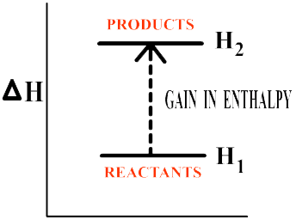
EXOTHERMIC REACTION
All those chemical in which heat is released in going from reactant to product are known as exothermic reactions.
For example
3H₂ + N₂ ➔ 2NH₃ + Heat
2SO₂+O₂ ➔ 2SO₃ + Heat
Graphical Representation
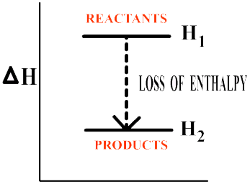
CHEMICAL REACTION
A process in which chemical change in the nature and composition of substances occurs is called chemical reaction
For example
CaCO₃ + HEAT➔ CO₂ + CaO
3H₂ + N₂ ➔ 2NH₃
CHEMICAL EQUATION
A chemical equation is a symbolic formation of chemical change in terms of symbols and formula.
CHARACTERISTICS OF A CHEMICAL EQUATION
1. A chemical equation must be a representative of a chemical reaction.
2. It should represent molar quantities.
3. It should be balanced in terms of atoms and molecules of reactants and products.
For example:
2SO₂+O₂ ➔ 2SO₃
3H₂ + N₂ ➔ 2NH₃
LAW OF CONVERSATION OF MASS
The law of conservation of mass indicates that during any process, mass is neither created nor destroyed.
The law was put forward by a French chemist LAVOISER in 1785.
Law of conversation of mass states that :
- Mass can neither be created nor destroyed during a chemical reaction.
- During a chemical reaction total mass of products is equal to the total mass of reactant

