Chapter 8: Chemical Reactions:
Measuring Rates of Reactions:
In chemical reactions, reactants change into products, this sometimes brings some other changes with it like change in colour, pH, temperature or mass. This information can be used to measure the rates of reactions.

Measuring Volume of Gas Produced Per Unit Time:
This is the best method to use for reactions that produce a gas. The reaction should be preformed in a ceiled flask connected to a gas syringe. When the reaction starts, the volume of gas produced is measured every minute or so. For more accurate results, the reactants should be separated until the time is started. This could be achieved by putting one of the reactants in a tube with a thread that extends through the ceiling out of the flask. To start the reaction the thread must be pulled pouring the content of the tube into the flask, thus the reactants meet. The time is started at this moment.
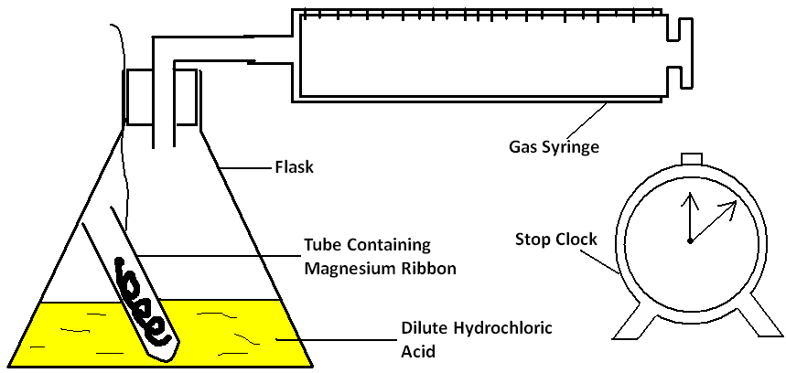

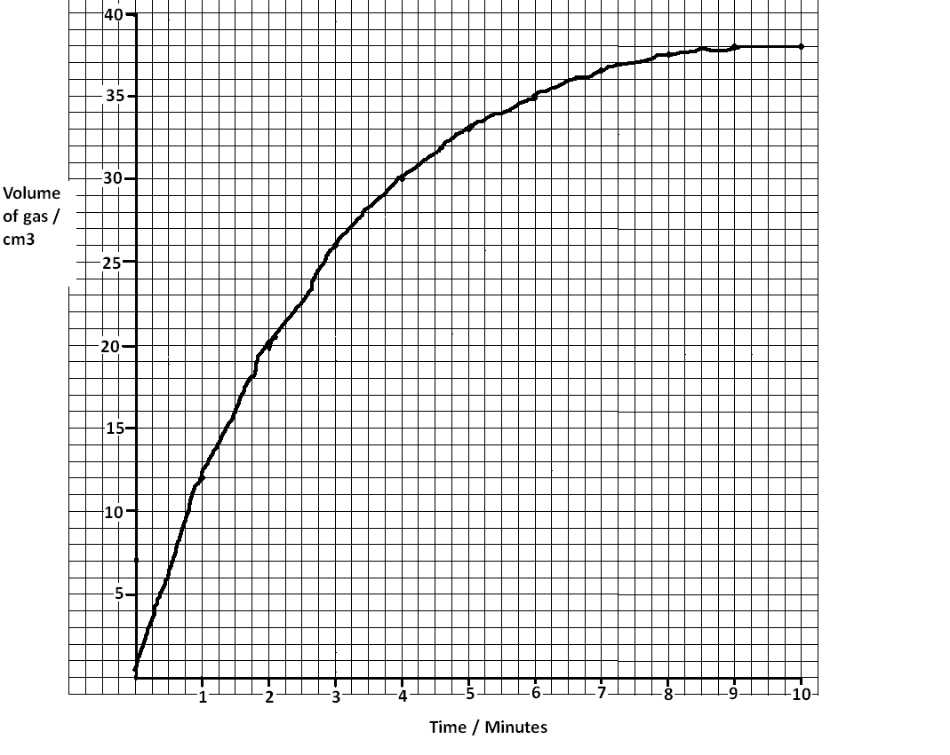
The previous figure shows a reaction between magnesium ribbon and hydrochloric acid. Hydrogen gas is one of the products and we will measure the volume of it produced every minute to find the rate of this reaction. Assume the results are as in the table, they can be plotted on a graph.
Time/Min | Volume/Cm³
0 | 0
1 | 12
2 | 20
3 | 26
4 | 30
5 | 33
6 | 35
7 | 36.5
8 | 37.5
9 | 38
10 | 38

- The steeper the curve the higher the rate
- When the curve is horizontal (like from 9-10 mins) no gas is being produced and the reaction is finished.
- The rate at given time is $\frac{Change in volume}{change in time}$
Example: rate at 2 mins: $\frac{20-12}{2-1} → \frac{8}{1}→8 cm^{3}/min$
- Average rate of the reaction is:$\frac{Total volume produced}{Total time taken}$
- Average rate of this reaction is : $\frac{38}{9}→4.2 cm^{3}/min$
- The reaction finishes after 9 minutes
- The rate is inversely proportional to the time taken to finish
Measuring The Drop in Mass:
For reactions in which one of the products is a gas, this method can be used. The reactants are put in a flask, the flask is placed on a balance. The initial mass of the flask and its content is measured and recorded. When the thread is pulled the reactants start reacting and the clock is started at the same time. The mass of the flask and its content is recorded every minute. A cotton wool is placed to allow gas produced to escape and prevents air from entering the flask causing error.
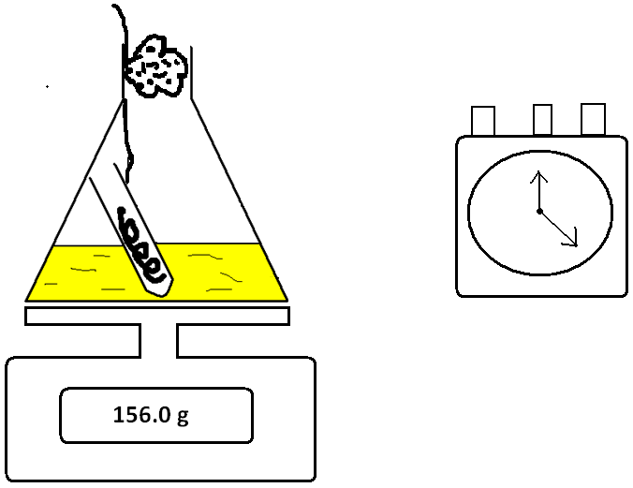

As the reaction proceeds, the gas evolves escapes through the cotton wool decreasing the mass of the flask and its content. The results will be as follows:
Time/Minutes | Mass of Flask & Content/g
0 | 156.0
1 | 154.0
2 | 152.0
3 | 152.2
4 | 150.7
5 | 150.7
6 | 150.7

The graph will look like this:
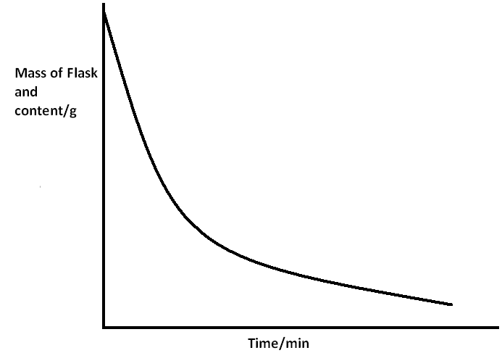

Measuring Time Taken For Cross To Disappear:
In some reactions, one of the products is an insoluble precipitate. In these reactions, the rate could be measured by performing it in a flask and placing the flask on a paper with a cross drawn on it. The time taken for the solution to go unclear enough for the cross to disappear is recorded.

But this is only one variable, so this method is used to investigate the rate of the reaction in different concentration of the reactants which is the second variable.

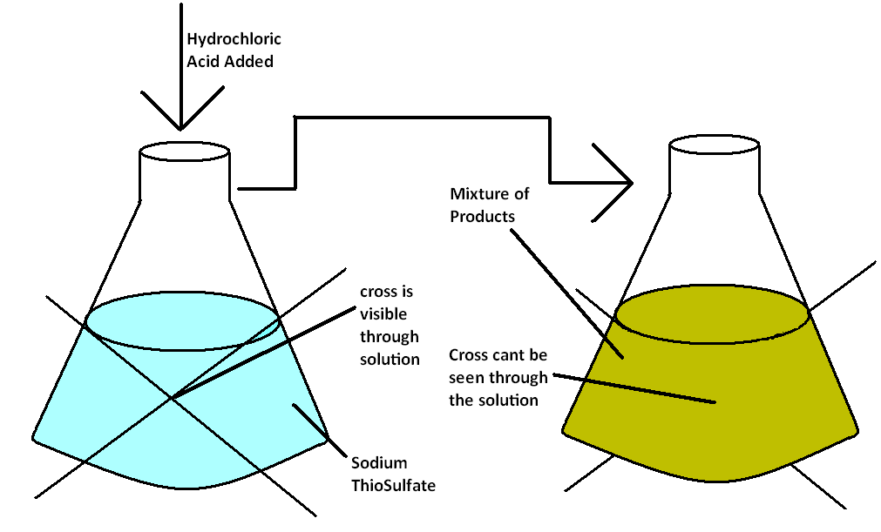
Sodium thiosulfuate reacts with hydrochloric acid producing sodium chloride, sulfur oxide, water and sulfur. The pure sulfur produced is a yellow precipitate. To investigate the rate of this reaction, we perform it several times with different concentrations of hydrochloric acid, and measure the time it takes for the sulfur precipitate to cover the cross.

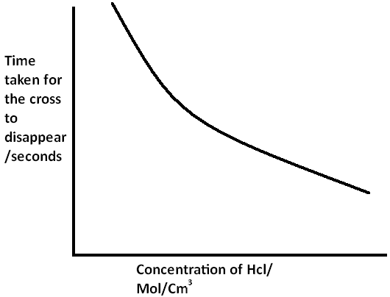
In each experiment, the concentration of the hydrochloric acid and the time taken for the cross to disappear are measured and recorded. These are the results:
Concentration  Of HCl Acid | Time Taken/ Sec
25 | 110
30 | 80
35 | 60
40 | 48
45 | 38
50 | 30
55 | 25

The concentration and time are inversely proportional. This is because as the concentration increases, more particles of the reactant are present, so frequency of effective collisions increase, thus the rate of the reaction increases.

Factors Affecting The Rate of Reactions:
In chemical reactions, there are several factors that determine its rate. If one of these factors is changed, the rate is affected. These are:
- Concentration of reactants
- Temperature
- Particle size (Surface Area)
- Catalyst
- Light (for photochemical reactions only)

Concentration of Reactants:
The concentration of the reactants is indirectly proportional to time taken for the reaction to finish. This is because as the concentration increases, more particles of the reactants are present, thus the frequency of effective collisions increase so the time taken for the reaction to finish decreases and the rate increases.

In a reaction, increasing the concentration of the reactant in excess speeds the reaction up without making a difference in the amount of the product. However, if we increase the concentration of the limiting reagent, the reaction speeds up and the amount of the product is increased. This is because there are more particles of the limiting reagent to react with available excess particles of substance in excess.

In an investigation, three apparatuses were set up as in the diagram. Each flask contained equal masses of magnesium of the same surface area, same volume of hydrochloric acid and all the reactions were performed in the same temperature. Each flask however had a different concentration of hydrochloric acid. Hydrochloric acid was in excess.
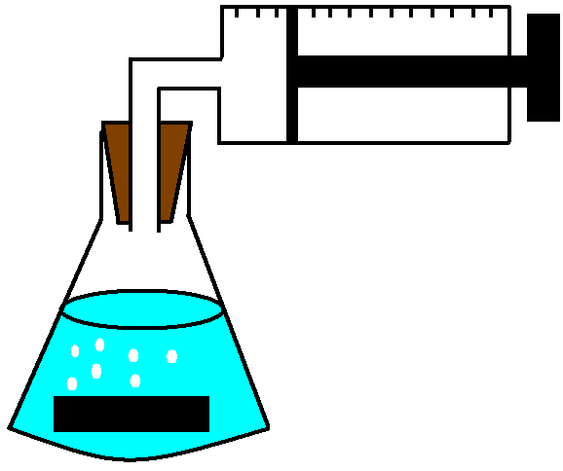
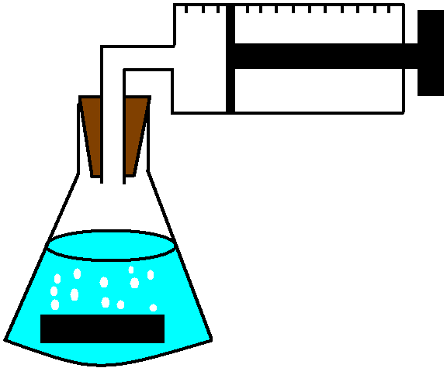
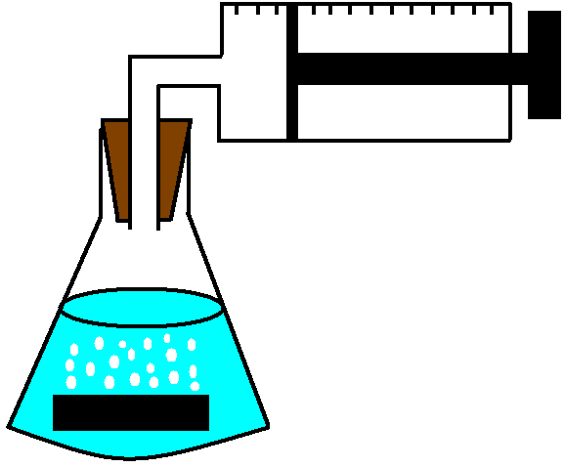
EXP 1: 0.5 Mol/dm³
EXP 2: 0.3 Mol/dm³

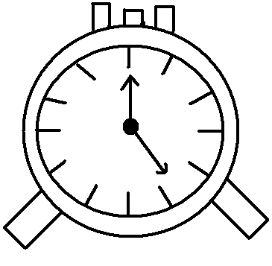

EXP 3: 0.1 Mol/dm³

Magnesium reacts with hydrochloric acid as follows:
Mg + 2 HCl $→$ MgCl₂ + H₂

This reaction finished when the volume of hydrogen gas being produced remains constant, the time taken to reach this point in each experiment was recorded. The results were plotted on a graph:
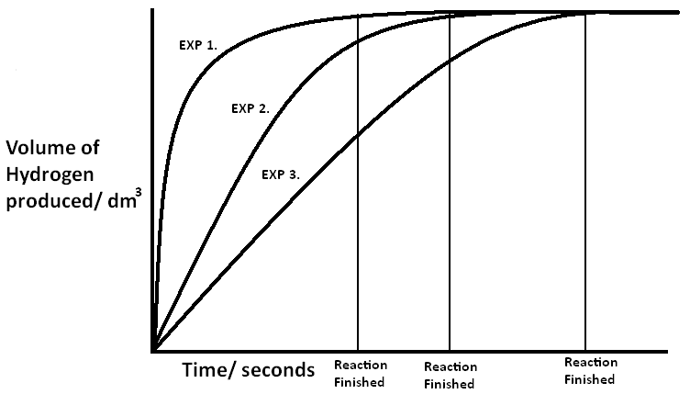
All experiments produced the same volume of gas because the concentration or amount of the limiting reagent was not changed. EXP 1. Was the fastest followed by EXP 2. And EXP 3. Was the slowest because of the difference in concentration of HCl. The faster the reaction the steeper the curve.

Temperature:
As the temperature of a reaction increases, the time taken for it to finish decreases and its rate increases. This is because the particles gain more kinetic energy and start to move faster and further apart so the frequency of effective collisions increase, thus the rate increases.

Zinc reacts with sulfuric acid as follows:
Zn + H₂SO₄ $→$ ZnSO₄ + H₂
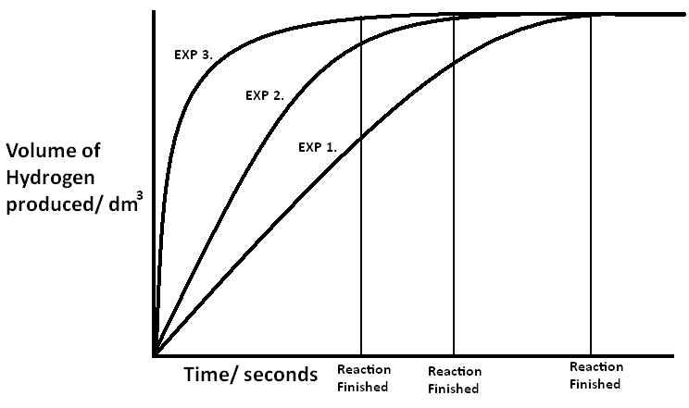
In an investigation, this reaction was performed 3 times. Experiment 1 was preformed at 20ºC, experiment 2 was performed at 30ºC and experiment 3 was performed at 50ºC. the results were plotted on a graph:

Experiment 1 has the least steep curve because its reaction was the slowest because it had the lowest temperature. Experiment 2’s curve is steeper than experiment 1’s because its reaction is faster because it had a higher temperature. Experiment 3 has the steepest curve because its reaction was the fastest because it had the highest temperature. All experiments produced the same volume of hydrogen because the amount or concentration of the reactants was not altered.

Particle Size (Surface Area):
In reactions in which one of the reactants is a solid. Increasing its surface area will increase the rate of the reaction. This is because in a reaction, the particles that react first are the particles on the surface of the solid because they meet the particles of the other reactant first. So increasing the surface area will increase the frequency of effective collisions and thus increase the rate. Particle size and surface area are inversely proportional, so if we have a block of sodium and we crush it down to smaller bits, its particle size decrease and the surface area increases, if we grind it into powder, the particle size will decrease more and the surface area will increase more. Powder has the largest surface are.

Calcium carbonate (Chalk) reacts with hydrochloric acid as follows:
CaCO₃ + 2HCl $→$ CaCl + CO₂ + H₂O
In an investigation, to investigate the effect of particle size on the rate of the reaction, this reaction was performed three times. In each reaction the same mass of chalk was used, same volume and concentration of acid was used and all three experiments were performed at the same temperature. The only factor that was changed was the surface area of chalk. In experiment 1, one large block of chalk was used. In experiment 2, 3 smaller blocks of chalk were used. In experiment 3, powdered chalk was used. the volume of Carbon dioxide produced and the time taken for each reaction to finish was measured.

The results were plotted on a graph: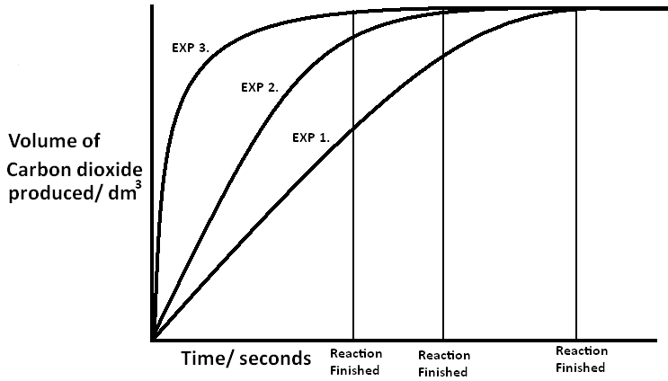

Experiment 3 was the fastest because the chalk in it had the largest surface area (powder form). Experiment 2 was slower because the chalk in it had a smaller surface area (small blocks). Experiment 1 was the slowest because it had the chalk in it had the smallest surface area (large block). All reactions produced the same volume of CO₂ because the mass of chalk and volume and concentration of HCl was constant in all three experiments.

Remember: experiments are finished when the volume of CO₂ being produced remains constant.

Catalysts:
A catalyst is a substance that increases the rate of a chemical reaction and remains unchanged. When a catalyst is added to a substance, it speeds it up without interfering.

Hydrogen peroxide decomposes to water and oxygen. This process however is very slow on its own. When a catalyst (Manganese (iv) oxide)
Is used, this reaction becomes very rapid.

2H₂O₂ $→$ 2H₂O + O₂

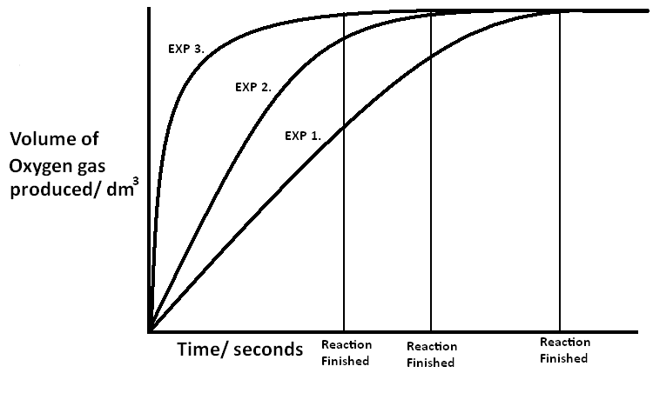
In an investigation to investigate the effect of a catalyst on this reaction, the reaction was preformed 3 times. In experiment one, no catalyst was used. in experiment 2, 5g of manganese (iv) oxide were used. in experiment 3, 10g of manganese (iv) oxide were used. in all three reactions, the same volume and concentration of Hydrogen peroxide was used and they were all performed at the same temperature.The time taken for the reaction to finish and volume of oxygen gas produced were measured. The results were plotted on a graph:

In experiment 1, no catalyst was used, so the reaction was very slow, this is why the curve is the least steep. In experiment 2, 5g of catalyst were used, so it was faster than experiment 1 so the curve is steeper. In experiment 3, 10g of the catalyst were used, so the reaction was fastest and curve is the steepest. All reactions produced the same volume of oxygen because the same volume of hydrogen peroxide was used in all three reactions.

Humans have in their bodies substances called Enzymes these are biological catalysts that speed up metabolic reactions in the body. Hydrogen peroxide is very toxic, when it is formed in the body, an enzyme Catalase quickly breaks it down into oxygen and water. This is why blood can be used as a catalyst for this experiment.

The Curve:
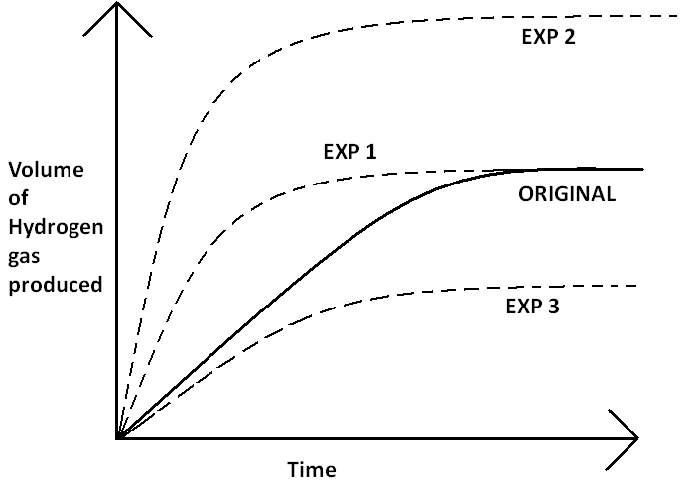
In this graph, the curve
In bold Is the original
Experiment. The dotted
Curves are the same
Experiment repeated
But with changing a
Factor. From this
Graph, we could predict the
Change in each experiment.
The original experiment was
Between magnesium and hydrochloric
Acid in which hydrochloric acid was in excess and magnesium was the limiting reagent. Mg + 2HCl $→$ MgCl₂ + H₂

- In EXP 1, the volume of product was the same but the reaction was faster. The change could be:
- Temperature Increased
- Catalyst is used
- Magnesium was used as powder
- Concentration of hydrochloric acid increased.

- In EXP 2, the reaction was faster and the more hydrogen was formed.
The change must be an increase in the amount of limiting reagent (Magnesium)

- In EXP 3. The reaction is slower and less gas was formed. The amount of limiting reagent (Magnesium) must have decreased.

